Complimentary Tour Booking Form
To welcome delegates to the amazing island of Guam for PAS 2016, Guam Visitors Bureau invites you to join a special complimentary half-day tour programme that gives you a fantastic opportunity to experience some of the island’s many cultural and historical attractions.

Pre-booking is essential as each tour is limited to 50 participants. All booking confirmations are made on a ‘first come-first served’ basis and exclusively for REGISTERED PAS2016 DELEGATES and SPOUSE only.

Complete this form and send it to Ms. Breeana Quitugua at breeana.quitugua@visitguam.org.

☐ Mr. ☐ Mrs. ☐ Ms.
First Name: |  | Surname:
Company: |  | Email:
Address: |  | Tel. (in case of emergency):
 |  | Country:
Arrival date into Guam: |  | Flight number:
Departure date from Guam: |  | Flight number:
Hotel in Guam:
Accompanying Person ☐ Yes ☐ No (If Yes: Name: )
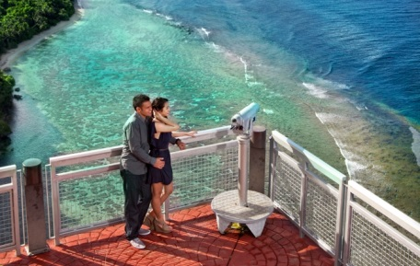
☐ Island City Tour

Experiencing Guam’s culture and history by walking through historical sites such as Putan Dos Amantes, Fort Agueda, Plaza De Espana, Latte Stone Park, etc..

Date: May 18 ☐ May 22 ☐

Time: 9:00 a.m. - 12:00 p.m. (no lunch included)

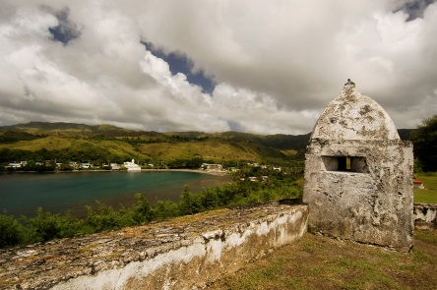
☐ Southern Island Tour

Exploring historic preservation and shared stories found across the landscapes at the T. Stell Newman, Cetti Bay, village of Umatac, etc.

Date: May 18 ☐ May 22 ☐ (please select one)

Time: 9:00 a.m. - 12:00 p.m. (no lunch included)

*** Click for full details of the above tours and shopping privileges
*** Pick up and drop off at each official hotel.
*** Delegate can join different tour on different date.

